SIMPLE STEP-BY-STEP PROCEDURE TO REGISTER IN BSNL CUSTOMER PORTAL
(To know your BSNL broadband usage, Duplicate bill, Local call details etc.)
(IMPORTANT:Open this page only with "Internet Explorer Browser")
First CLICK HERE
You will get like below page and
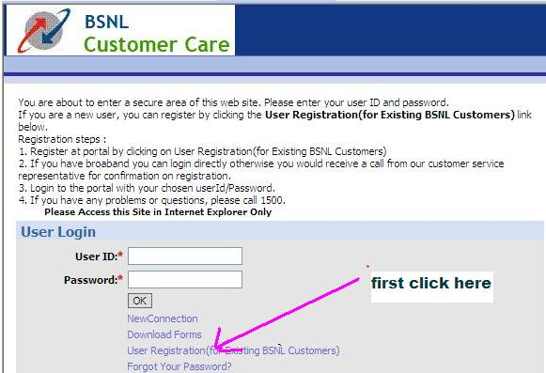
click “User Registration(for Existing BSNL Customers)” as shown above
Now you will get like below page 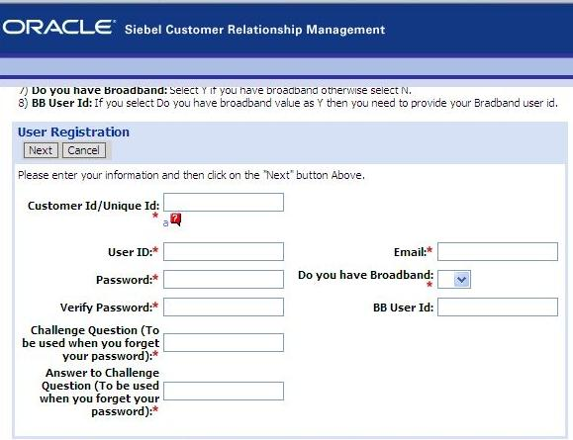

Fill this page as below one by one
- Customer Id/Unique Id: 
You can find your customer ID like below
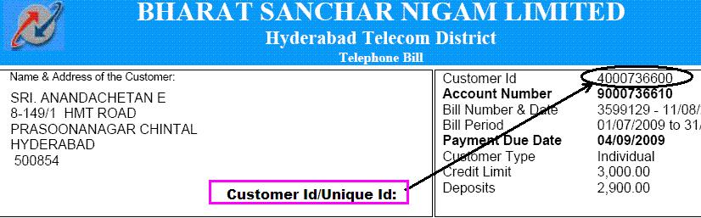
2. User ID:
You can choose ur own like ….. kumar22 (example)
3. Password:
You can choose ur own like ……….password22 (example)
4. Verify Password:
Fill here same above …………….password22 (example)
5. Challenge Question (To be used when you forget your password):
Fill here like ………….What is your birth place? (example)
6. Answer to Challenge Question (To be used when you forget your password):
Here fill the answer for the above…….. Chennai
7. Email:
Here fill your Email id
If you don’t have Email id CLICK HERE TO create a ur Gmail id
8. Do you have Broadband:
Here answer………………………… “Y”
9. BB User Id:
You can find your BB User id like below
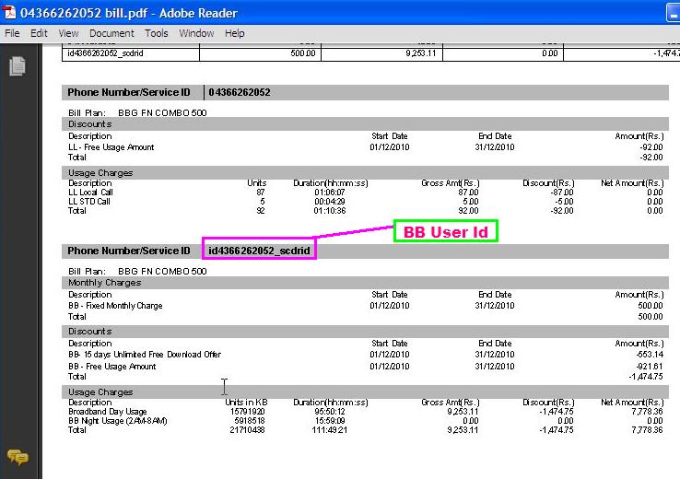

After completion of the above click login page
And enter your username and password
Your will get like below page
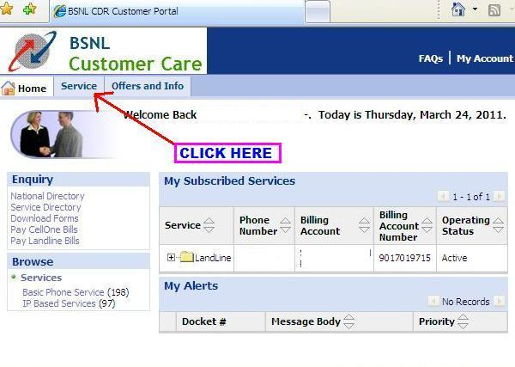
Now Click your option as per your need.
